Title

A Thesis Presented to

The Faculty of the Computer Science Program

California State University Channel Islands

In (Partial) Fulfillment

of the Requirements for the Degree

Masters of Science in Computer Science

by

Jane Cathy Doe

May 2007

© 2007
Jane Cathy Doe
ALL RIGHTS RESERVED

APPROVED FOR THE COMPUTER SCIENCE PROGRAM

________________________________________________

Advisor: Dr. Andrzej Bieszczad Date

________________________________________________

Dr. William Wolfe Date

________________________________________________

Dr. Peter Smith Date

APPROVED FOR THE UNIVERSITY

________________________________________________

Dr. Gary A. Berg Date

Title

by

Jane Cathy Doe

Computer Science Program

California State University Channel Islands

Abstract

This thesis…

Acknowledgements

The author would like to….

TABLE OF CONTENT

Chapter 1: Introduction 8
1.1 Introduction to … 8
1.2 Section 2 8
1.3 Remaining Chapters 8
1.4 Key Terms 9
Chapter 2: Field Overview 10
2.1 Section title 10
2.2 Section 2 11
2.3 Section 11
3.2.1 Subsection 11
Chapter 3: Technical details of the work 13
3.1 Overview 13
Chapter 4: Experiments 14
4.1 Setup… 14
Chapter 5: Analysis of Results 15
5.1 Section 15
5.2 Section 15
Chapter 6: Conclusions 17
6.1 Here… 17
Chapter 7: Future Work 18
TABLE OF FIGURES

Figure 1. Traditional Finite State Machine with four states 11
Figure 2. Caption... 12

Introduction

Introduction to …

Introduction…

Section 2

Another section…

Remaining Chapters

In the second chapter, we will analyze some of the different…

In the third chapter, we will discuss …

The fourth chapter will discuss how we set up the game from a visual and game engine standpoint. We will discuss the environment being used, and how the enemy agents and the player were set up in Torque.

In the fifth chapter, we will begin to discuss …

The sixth chapter will be a look at…

The seventh and final chapter will include a summary of the project’s results. This chapter will also compare and contrast different learning techniques... What remains unsolved and what could be added to further enhance the project will also be discussed.

Key Terms

Game AI - Artificial intelligence in video games.
Agent – An object in the game that is controlled by the AI system.

Field Overview

There are quite a few different techniques...

Section title

The most used technique when … presented in [2]...

A simple FSM illustration can be seen in Figure 1.

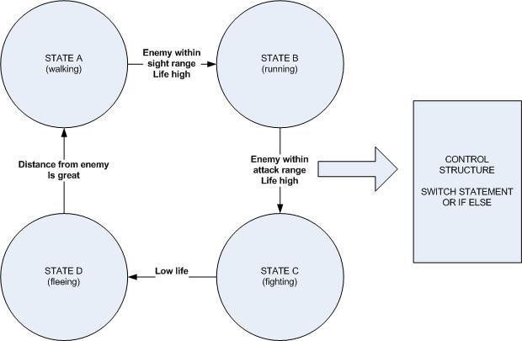
- Traditional Finite State Machine with four states

FSMs are most commonly used to …. complex state diagrams [4].

Another aspect...

Section 2

xxxxxxx

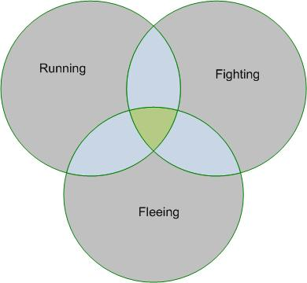
- Caption...

The ability to …

The concept of ….

Section

Subsection

Another…

Sub-sub-section

Sub-sub-section text…

Technical details of the work

Overview

Text...

Experiments

Setup…

Text..

Analysis of Results

Section

Text…

Section

Text…
Snippet:

static int uiInitialize(int argc, char **argv);
static int uiMainLoop();
static void display();
static void reshape();
static void Init();
static void resetView();
static void idleFunc();
static void createMenu(void);
static void menu(int value);

Conclusions

Here…

Conclude…

Future Work

Ideas….

References

- “Title” by Author, Springer Verlag, Berlin, 1998.
- “Another Title” by Another Author, Another Publisher, Located, Year.

This is a footnote

